Little SPARK: Simple Play Adaptations to Reference for Kids

Ultimate Fidget Fidgipod
Description: | Image:
Fidget tool featuring 100's of soft rubbery spiky bristles, chunky sensory spokes around the rim, and a 1" deep spider-web design on the non-skid bottom.  Purchasing Information | 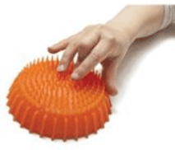

Who Might Benefit?
Those who seek sensory input throughout the day, prefer movement to focus, engage in touching, poking, or fidgeting with items to calm themselves.
Why Use?
Quiet sensory exploration and self-calming tool that can help a child’s focus and regulation.
Instructions for Use: | Adaptation Ideas:
Environmental Considerations  Use in all settings during large group activities, small group activities, and one-on-one instruction.  Positioning & Alternate Positioning  - Use in any position; seated, standing, on the floor, etc. with a slanted surface or propped up.  Basic Play/Use  - Open ended exploration.  Play/Use with Others  - Take turns playing “I can…” game (e.g. I can poke it with my fingers). | Stabilize It  - Use Velcro or Dycem or add a handle.  Contain It  - Store in open container alone or sensory tub with other items.  Add Sensory Cues  - Label colors and shapes with print words and braille in environment.  Communication Supports  - Visual supports like communication cards and social narratives can help a child communicate their feelings.  DIY Alternatives  - Textured balls at discount or pet stores.  - Bean bags or squeeze balls with various textures.

Words to Encourage Play/Use
Touch   | Poke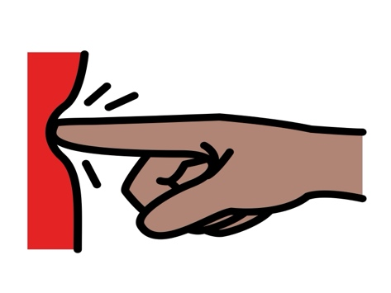 | Calm 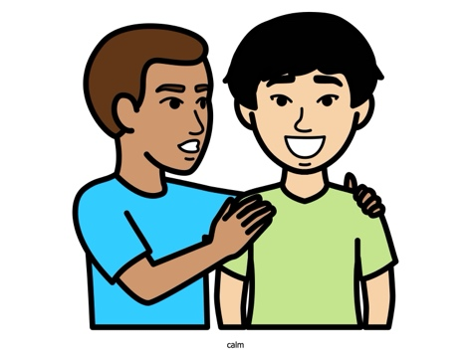
Quiet | Hands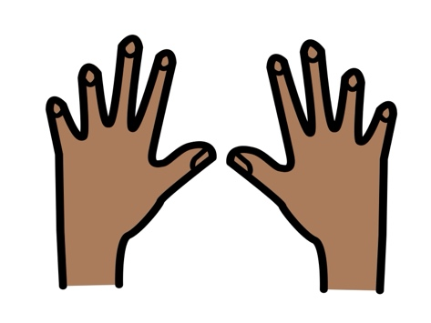 | Fingers
Help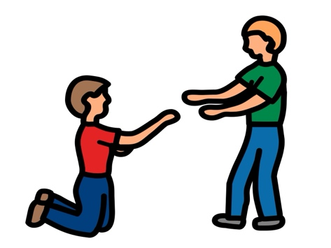 | On | Off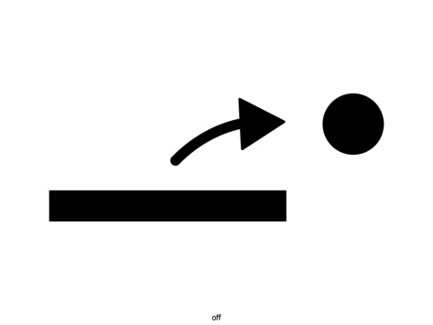
*”Adaptations” adapted from: Haugen’s Modes for Adapting Toys based on materials from the "Let's Play" Project at the University of Buffalo
PCS is a trademark of Tobii Dynavox, LLC. All rights reserved. Used with permission.

